Wireframe Document

Heart Disease Diagnostic Analysis

Revision Number :1.4

Last Date of Revision :13-04-2023

Mangesh Shinde

**We Performed Exploratory Data Analysis on Jupyter Notebook and then created a Power BI Desktop Dashboard.**

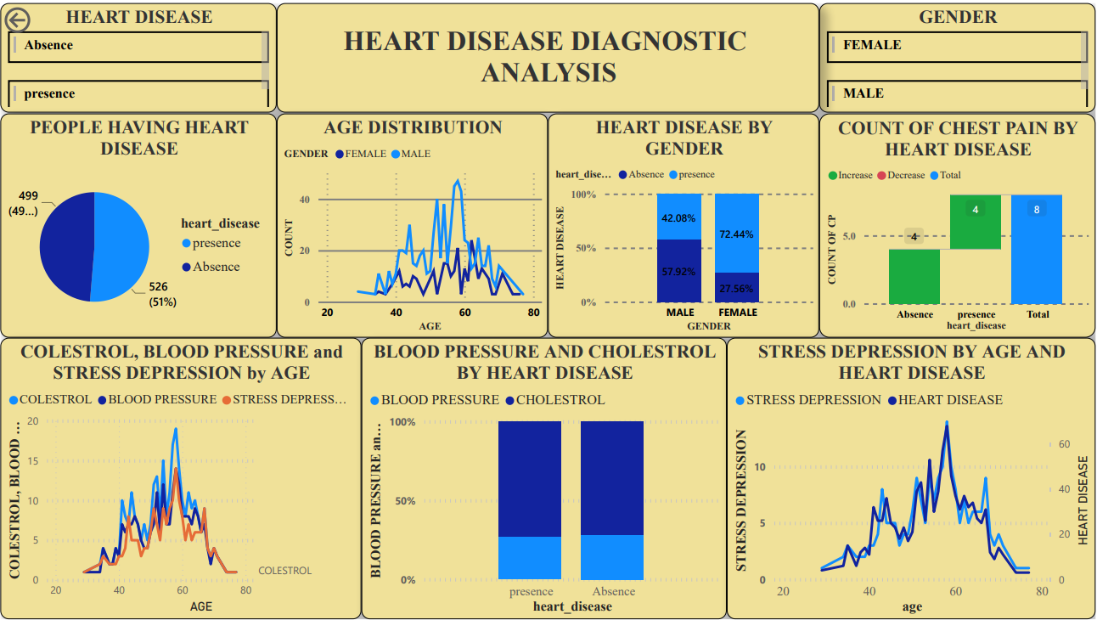

# What Kind of Population do we have?

# 

* + 49% People suffering from heart disease.

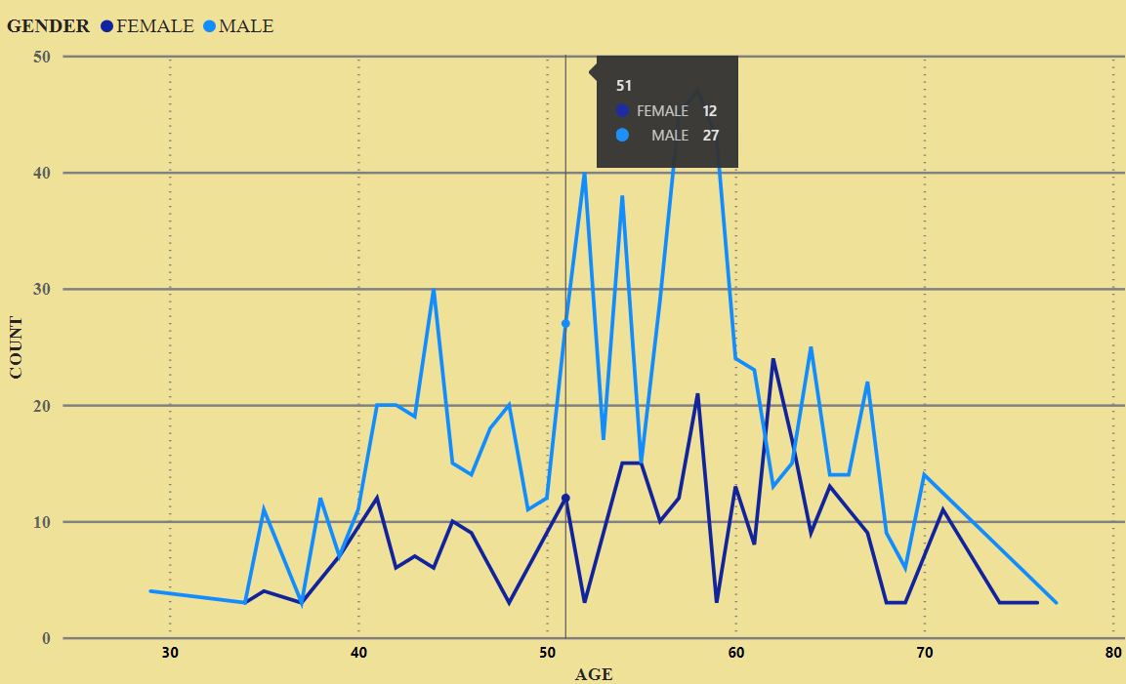

* + Elderly Aged Men are more (50 to 60 Years) and Females are more in 55 to 65 Years Category

# Who Suffer from Heart Disease?

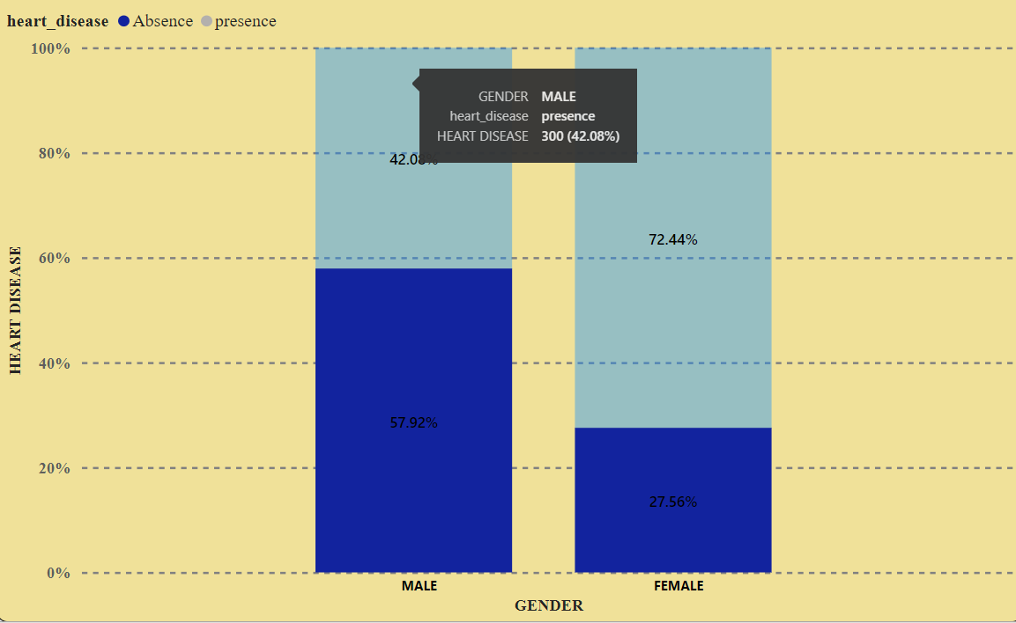

* + Males are more prone to heart disease.
  + Elderly Aged People are more prone to heart disease.

# What symptoms people experience in heart disease?

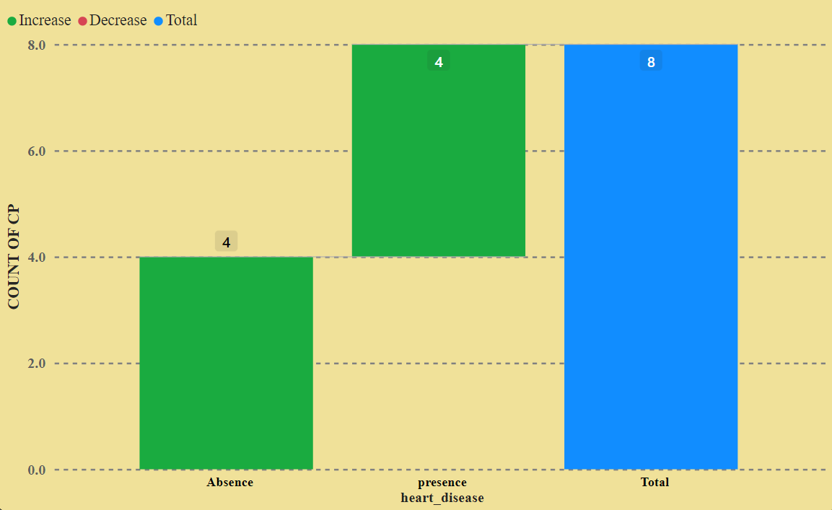

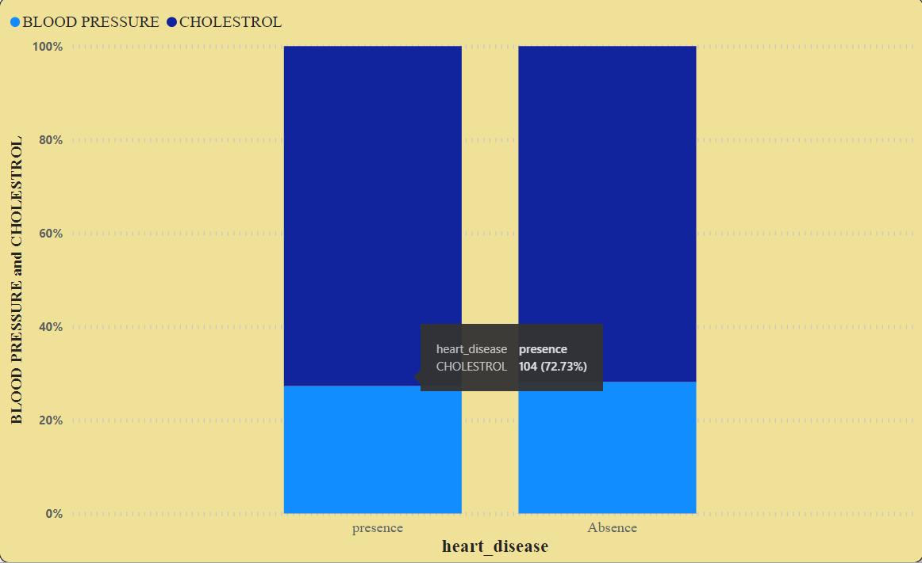

* It seems people having Typical Angina Cheast Pain Have a Higher Chance Of Heart Disease.
* Typical Angina Cheast Pain Means often Triggered By Physical Or Emotional Stress.
* It seems high number of cholesterol level in people

having heart disease.

# 

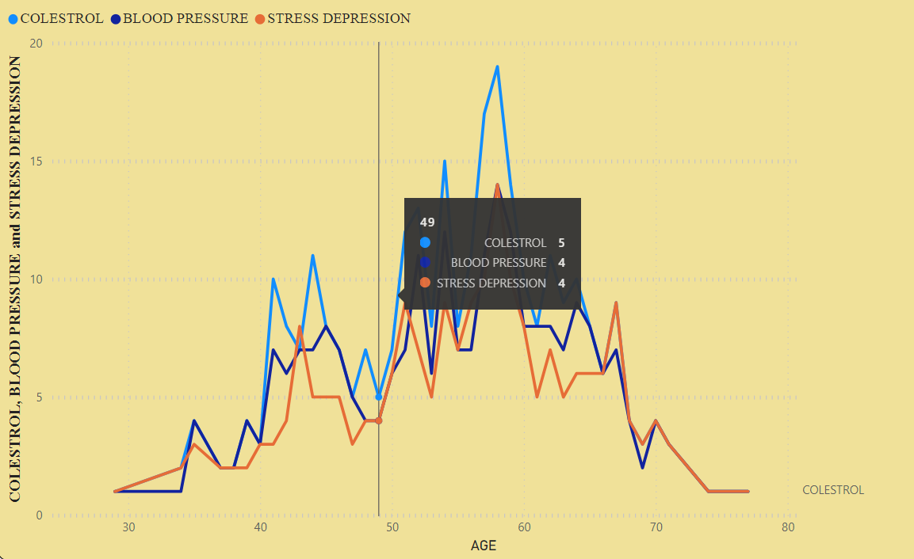

* Here we can observe that Blood Pressure increases between age of 50 to 60 and somehow continue the pattern till 70.
* Similarly, Cholesterol and maximum heart rate Increasing in the age group of 50-60.

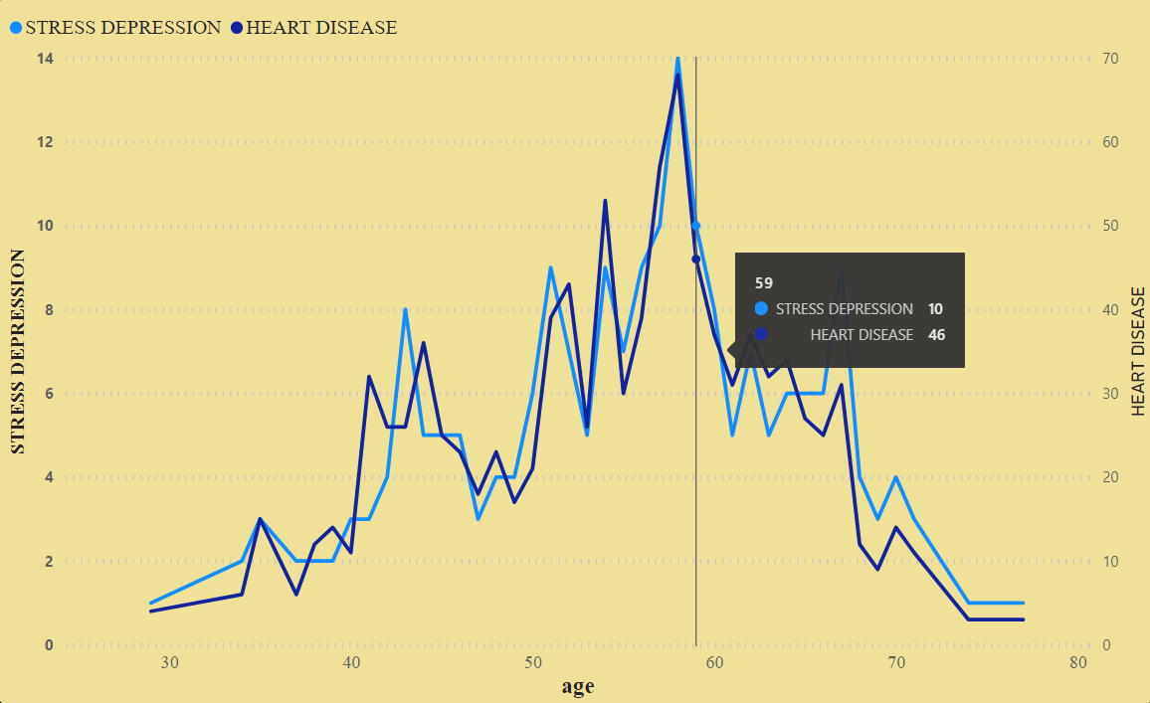

* we can observe from here that ST depression mostly increases between the age group of 30-40.
* ST depression refers to a finding on an electrocardiogram, wherein the trace in the ST segment is abnormally low below the baseline.